20TH CENTURY people’s LIVES
Students define vocabulary relating to life stories and learn about the past simple of the irregular verb "to be". The lesson gives practice in listening, reading, writing and speaking and there is a short optional extension activity related to the pronunciation of unstressed forms in sentences.

- Warm up
Match the beginnings and endings of these phrases about people’s lives.
1. to be born in a. 1965
2. to be famous for b. his paintings
3. to be from c. Japanese
4. to be a d. London
5. to be Canadian or e. poor
6. to be married or f. divorced
7. to be beautiful or g. handsome
8. to be rich or h. writer

Which adjectives are opposites?
Which pair of adjectives refer to women and men?
Think of one more way to end the first five phrases
- Reading
These photos show three famous people from the 20th century. Match the photos to the texts. Then complete the life story about each person using the words in the box
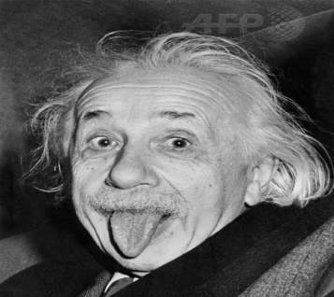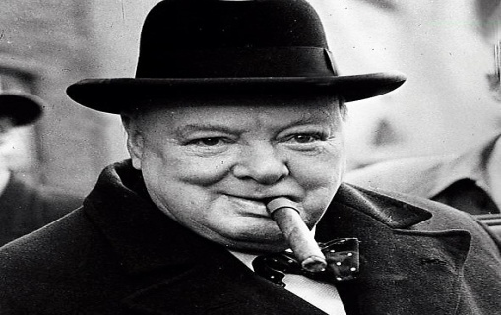
music | scientist | Britain | 1935
singer | rich | pianist | poor
Text 1: Elvis Presley
He was a famous American ………………….1 . He was famous for his ……………..2 . He was born in ……………………………3 in Mississippi, USA. His parents were very ………………………………4 - it was a difficult time in the American economy.

Text 2: Albert Einstein
He was a German ………………..5 . He was famous for his theory of relativity. He was born in 1879 in Germany. His father was a businessman and his mother was a …………………6 .

Text 3: Winston Churchill
He was the prime minister of ……………….7 from 1940-1945 and 1950-1951. He was born in England in 1874. His parents were ………………………8 and famous - his father was a politician and his mother was the daughter of an American millionaire.

- Language point
Study these sentences.
- Elvis Presley was a famous American singer.
- Albert Einstein was born in 1879 in Germany.
- Elvis Presley’s parents were very poor.
- Winston Churchill’s parents were rich and famous.
Was and were are the past tense forms of the irregular verb to be. Study the table below. Then choose the best answers to the questions.
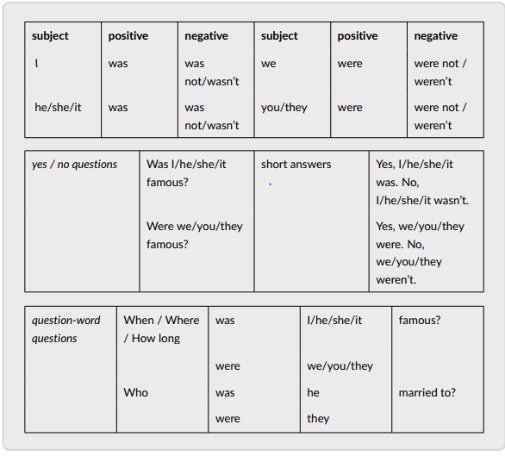
- In the past tense, we use different / the same forms of to be with I and he/she/it.
- We make / don’t make contractions with positive sentences with to be in the past tense.
- We use contractions with negative forms when we want to be informal / formal.
- We repeat / don’t repeat the adjective when we give a short answer to a yes/noquestion.
How are the past and present forms of to be different? Compare the number of forms and the use of contractions.

- Practice
Read the life stories of two famous African American women. Use the information to write the missing questions or answers. Write full sentences. The examples will help you.
Examples See the question, write the answer:
- Was Aretha Franklin from a small family? No, she wasn’t. She was from a big family.
See the answer, write the question:
- Where was Aretha Franklin born? She was born in Memphis.

Text A
Aretha Franklin was a famous singer and songwriter. She was the first woman in the Rock and Roll Hall of Fame. She was born in 1942 in Memphis. She was from a big family. Her parents were friends with lots of famous singers.

- Was Aretha Franklin a famous scientist?............................................................................................. .
- …………………………………………………………………………… ? Aretha Franklin was the first woman in the Rock and Roll Hall of Fame.
- When was Aretha Franklin born?........................................................................................................ .
- ……………………………………………………………………………… ? They were friends with lots of famous singers.

Text B
Althea Gibson was a famous sportswoman. She was the first African American woman to play tennis internationally. She was born in 1927 in South Carolina, USA. Her parents were farmers. She was the winner of Wimbledon in 1957 and 1958.

- Who was Althea Gibson?......................................................................................... .
- Was Althea Gibson the first African American woman to play tennis in the US? ………………………………………………………………………………...
- ……………………………………………………………….. ? She was born in South Carolina, USA.
- ………………………………………………………………… ? Yes, they were. Her parents were farmers.

- Writing and speaking
Read about two more famous women. Work in A/B pairs. Student A, read about Agatha Christie and Student B, read about Tove Jansson.
- There is some information missing from your texts and your partner has the answers. Work alone to write questions to ask your partner. Use the words you are given.
- Then ask and answer questions together and write the missing information in the text.
- After you finish speaking, show your partner the pictures on your page. Then tell your partner if you know these writers and enjoy their books.

Student A
Read and write questions about Agatha Christie. Give information about Tove Jansson
1. Agatha Christie was ....
2. She was ....
3. She was born in ....
4. She was famous for .................................... Hercule Poirot and Miss Marple.
5. Hercule Poirot and Miss Marple were ....
6. She was married ....

Use these words to write your questions:
- Who ...
- Where ...
- When ...
- What ...
- Who were ...
- How many times ...
Use this text to answer your partner’s questions. Speak in full sentences.
Text 1
Tove Jansson was a writer and artist. She was born in 1914. She was from Finland. She was famous for her books about the Moomins. The Moomins were little animals who lived in the forest. Jansson’s parents were artists too.

Student B
Read and write questions about Tove Jansson. Use the words you are given to help you make questions. Give information about Agatha Christie.
1. Tove Jansson was a ....
2. She was born ....
3. She was from ....
4. She was famous for .................................... the Moomins.
5. The Moomins were ....
6. Jansson’s parents were ....

Use these words to write your questions:
- Who ...
- When ...
- Where ...
- What ...
- Who were ...
- Were ...too?
Use this text to answer your partner’s questions. Speak in full sentences.

Text 2
Agatha Christiewas a famous writer. She was English. She was born in 1890. She was famous for her books about Hercule Poirot and Miss Marple. They were very clever detectives. She was married twice

- Extra practice/homework
Read the life stories of two politicians and the questions about them. Find ten grammar mistakes and correct them. Three of the sentences are correct.
- Shirley Chisholm was a famous American politician.
- She born in New York in 1924.
- Her parents was from Barbados and Guyana.
- She was first African American woman to join the US Congress.
- She was famous helping women and children.
- Where Shirley Chisholm’s parents from?

- Barbara Castle a famous British politician.
- She was of the North of England.
- She was student at Oxford University.
- She was a Member of Parliament for the Labour party for 34 years.
- She was famous making laws about transport safety.
- She and her husband Ted were very interested in their nieces and nephews.
- Barbara Castle was married?

- Optional extension
In English, we stress the information words in a sentence. This means we say these words more strongly: louder and longer. If some words are stressed, other words sound weak, or unstressed (softer and shorter). Unstressed words are usually grammar words. Understanding stressed and weak words helps you listen and speak better in English.
Listen to the sentences about Elvis Presley and notice the strong and weak words. Then practise saying the sentences like the recording.
- He was a famous American singer.
- He was famous for hismusic.
- He was born in 1935 in Mississippi, USA.
- His parents were very poor– it was a difficult time in the American economy.
Now mark the strong and (weak) words for these sentences about Albert Einstein. Listen and check your ideas.
Practise saying the sentences with stressed and weak words.
- He was a German scientist.
- He was famous for his theory of relativity.
- He was born in 1879 in Germany.
- His father was a businessman and his mother was a pianist

Madame Boufrioua

